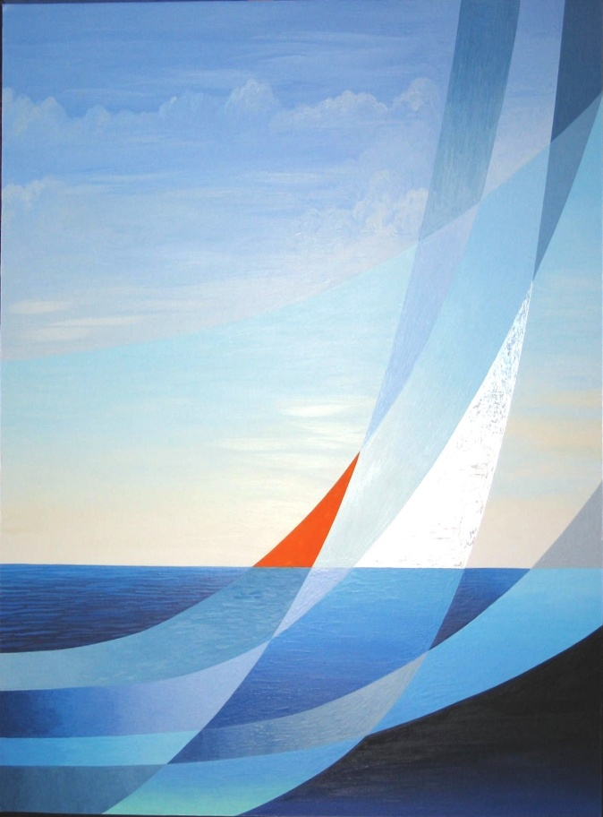

## Race Registration form

**To register**, **please fill out one form per person. Extra forms are available on-line at the Van Buren Point website. Please print clearly. Mail completed form to: Holly Voelp 5649 Lakeside Blvd. Van Buren Point, NY 14166.**

First Name: Last Name:

Address:

Email: cell phone

Age as of July: Gender:

Please Check:

I will ____run ___walk in the ____5K ____1 K children’s race

T-shirt size: Adult ___S ___M ___L ___XL ____XXL

Child ___ S ____M ____L

Emergency Contact: Phone:

**Liability Waiver and Race Agreement**

___I know that participation in the VBP 5K and 1 Mile Walk/Run is a potentially hazardous activity. I should not enter and participate unless I am medically able and properly trained. I assume all risks associated with participation in the said event. Activities including, but not limited to falling, contact with other participants, contact with any equipment being used by me or around me, the effects of weather, traffic and the conditions of the roads or pavement, and all such risks being known and appreciated by me. Having read this waiver and knowing these facts and in consideration of your accepting my application, I, for myself and anyone entitled to act in my behalf, waive and release any and all sponsors including but not limited to, VBP Women’s Association, VBP Association, property owners, their employees, race officials, volunteers, and all sponsors, the representatives, and successors from all claims of liability of any kind arising out of negligence or carelessness on the part of the persons named in this waiver.

**Registration Fee** ($25 for 5K and walk, $10 for 1 K Children’s Run

_____ I will make a check payable to Van Buren Point Association (add VBP 5K) in memo line and submit it with this form

**Signature** of participant or his/her parent/guardian **Date**

Get to the POINT!

Van Buren Point

5th Annual

5K Run/WALK

July 1, 2018

## MAke a “Point” to Join Us…

**In running our fourth VBP 5K race for new Community Center floors on July 1, 2018!**

**Bring your family and friends, and walk or run the streets of summer at VBP!**

Get to the POINT…

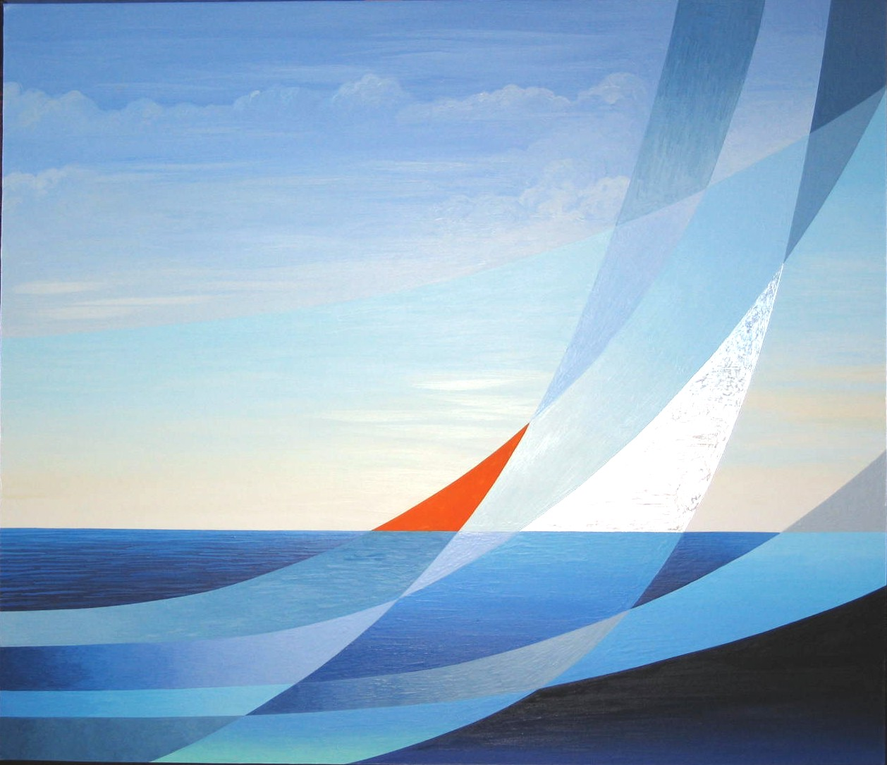

*Please remember to pick up your race day tshirt, number and chip between 8-9AM on July 6 at the Community Center*

## 

## Why Run?

**All proceeds of the race** will be used for renovating Community Center.

**Sponsorship: Business Sponsors -** $100 for name on t-shirts/ $200 for name and logo on t-shirts

**Cottage Name Sponsors -** $100 for your cottage’s name on t-shirt.

All requests for cottage name or Business must be placed 2 weeks before the race.

Please send checks (payable to Van Buren Point Association) to Holly Voelp, 5649 Lakeside Blvd., Van Buren Point, NY 14166

## 

## About the Race

**The race** will begin at the VBP Community Center at 9 AM. The course will wind around the Point and will finish where it began.

**To participate,** please fill out the registration form and mail to Holly Voelp, 5649 Lakeside Blvd., Van Buren Point, NY 14166.

**Registration Fees:** $25 for each 5K runner or walker

$10 for each 1 K children’s race runner - under 10 years of age

**The first 150 people to register will be guaranteed a t-shirt.**